# Guide To Save

**# Source**: **Chatgpt (GPT-5-Standard) at [8/29/2025]**

In **Commandos: Behind Enemy Lines (110 MB)**, the **save files** are not stored inside the main .exe or installation folder itself — they are usually kept in a **separate "Save" or "Output" folder** created by the game.

For the classic PC release, the save files are:

* **File type:** .SAV files
* **Default folder:** inside the game installation directory, usually named something like:

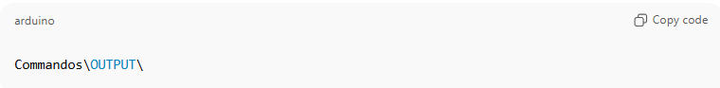

Commandos\OUTPUT\

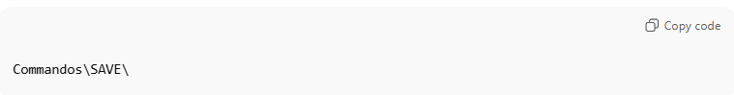 Commandos\SAVE\

Each save slot you create generates a .SAV file (sometimes also with a .MIS mission reference).

📌 For example, you might see files like:

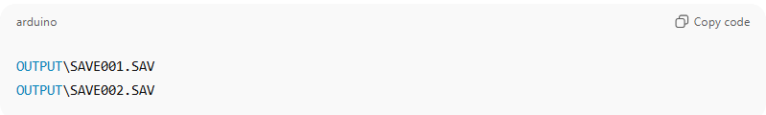

OUTPUT\SAVE001.SAV

OUTPUT\SAVE002.SAV

# Steps

**# Source**: **Windows ScreenShots From Windows -> Windows folder system at [8/29/2025]**

